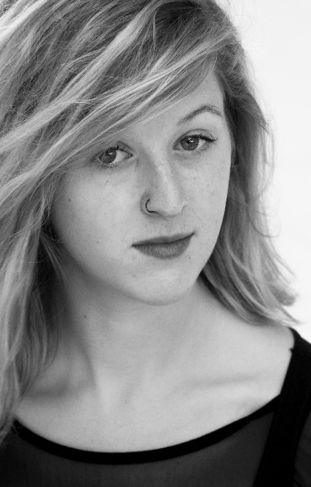
Hannah O’Reilly

Hair: Blonde
Eyes: Blue
Height: 5'3"
Build: slim/athletic
Shoe size 5.5 Dress size 10
Playing Age: 19-25

Accents/Dialects:
Ireland: General, Dublin, Northern Irish
UK: General, Scottish, Welsh
American: General, Southern,
Other: French, Australian

Credits:
Theatre | Role | Production (date) | Director
Professional | Una (leading)  Miranda (leading) | Blackbird (2015)  The Tempest (2013) | Des Hanrahan  Fiona O’Connor
 | Harper (Supporting) | Angels in America (2013) | Darragh O’Brien
 | Viola (leading) | Twelfth Night (2013) | Samuel Ferry
 | Lady Anne (Supporting) | Richard III (2012) | Samuel Ferry
University | Sarah (Leading) | PERVE (2012) | Andrew Flynn
 | Skinhead Girl (Supporting) | Polaroid Stories (2013) | Martin Kenny
 | Player King (Supporting) | Hamlet (2012) | Samuel Ferry
 | Frau Gabor (Supporting) | Spring Awakening (2012) | Soph Connolly
 | Juliet (leading) | Romeo and Juliet (2010) | Conor O’Grady
Film & Television
Professional | Maureen (Supporting)  Jen (leading)  Dancer  Lisa (leading)  Alanna (leading)  Victim (leading)  Niamh (leading)  Extra  Aisling (leading)  Emma (Supporting) | In My Father’s House (‘15)  Redial (2015)  Angel of Small Death (‘15)  The Suit (2015)  Lying Down (2014)  POKE (2014)  Mine and Yours (2013-14)  1916 Seachtar Na Cáisce  Unheard (2012)  Lucky Run (2010/11) | Maeve Hickey  Stephen Byrne  Emily Murray  Heather Curran  Susan Collins  Chris Tierney  Brian O’Brien  John Boorman  Carla Tighe  Colm Cafferkey

Skills: | - Singing  - Dancing  - Choreography  - Languages  - Art and Design | - Directing  - Full Driving  - License  - Music Arranging | - Archery  - Horse Riding  - French and Irish

Training:
- Ongoing Classical Ballet training, grade 5
- 2014 Abbey Actor’s training course with Theatre Lovett
- 2014 Wise Living Yoga Academy, teacher training
- 2013 Casting Workshop with Maureen Hughes and Irish Actors Guide
- 2010-2013 NUI, Galway: BA Hons. Theatre, French and English
- 2012 Blue Raincoat Theatre Company Training course in Corporeal Mime
- 2009 Gaiety School of Acting Certificate in Stanislavskian Acting
- 2009 Royal Irish Academy of Music Singing, Musical Theatre

